**"Titanic Survival Analysis - Data Visualization Project"**

**Dataset:** The dataset contains information about passengers aboard the Titanic, including features such as age, sex, passenger class, cabin, fare, and survival status.

**Data Source:** The dataset is available on Kaggle.

**Objective:** The objective of this project is to visualize and analyze the Titanic dataset to understand the factors that influenced passenger survival during the disaster.

**Tools and Libraries:** You can use the following Python libraries for data visualization:

* Pandas: For data manipulation and analysis.
* Matplotlib and Seaborn: For creating static visualizations.

**Data Visualization Tasks:**

1. Survival Distribution:

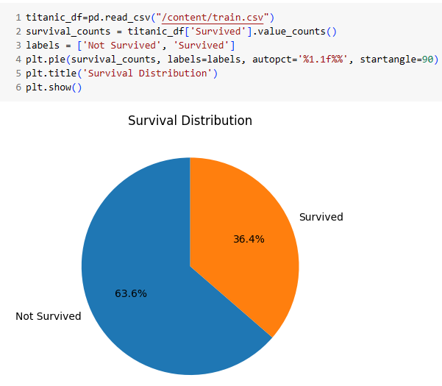

The conclusion is that the majority of passengers did not survive the Titanic disaster, with a significantly lower number of survivors.

1. Age and Gender Analysis:

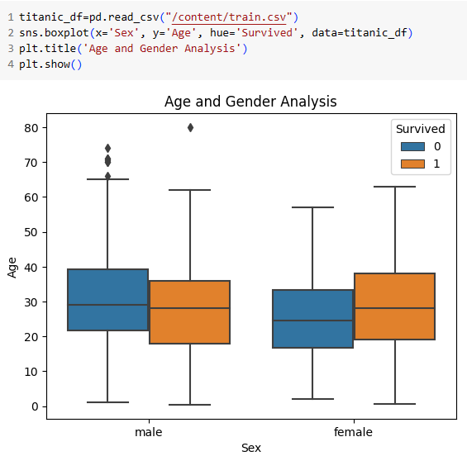

The conclusion is that :

* The age distribution of male and female passengers appears fairly similar, with slightly more male passengers in the dataset.
* Young children and the elderly seem to have a higher survival rate compared to other age groups.

1. Passenger Class Analysis:

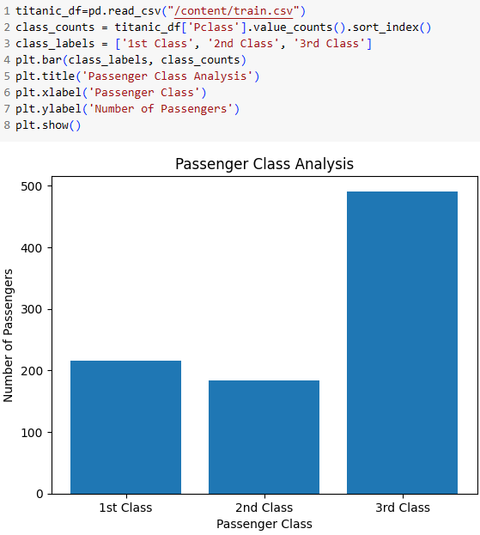

The conclusion is that :

* Most passengers were in the 3rd class, followed by the 1st and 2nd classes.
* Passengers in the 1st class had a higher chance of survival compared to those in the 2nd and 3rd classes, indicating a correlation between class and survival.

1. Fare Distribution:

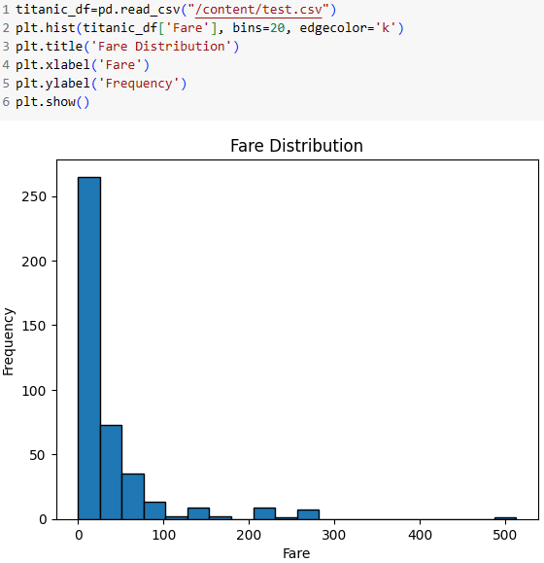

The conclusion is that :

* The fare distribution is positively skewed, with a majority of passengers paying lower fares.
* Passengers in the 1st class paid significantly higher fares than those in the 2nd and 3rd classes.

1. Embarked Port Analysis:

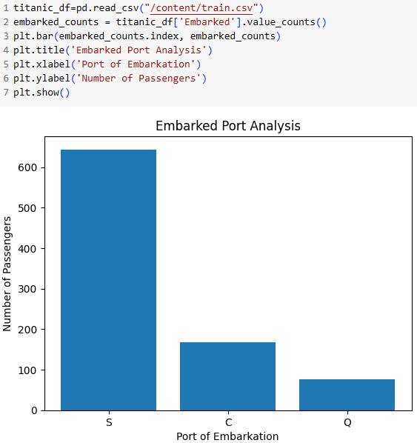

The conclusion is that :

* Most passengers boarded the Titanic in Southampton (S), followed by Cherbourg (C) and Queenstown (Q).
* The embarkation port may have an impact on survival, as passengers boarding in Cherbourg had a higher survival rate compared to the other ports.

1. Cabin and Deck Analysis:

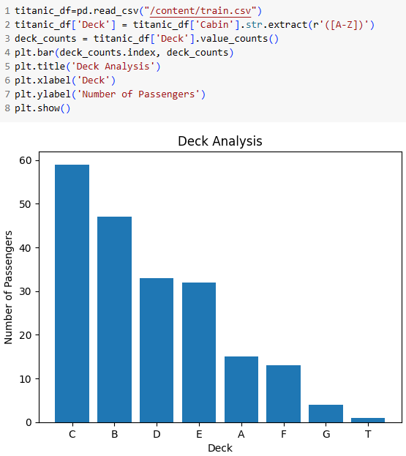

The conclusion is that :

* Passengers on different decks had varying survival rates.
* Passengers on the upper decks (e.g., Deck B, C, D) had higher survival rates compared to those on the lower decks.

1. Correlation Heatmap:

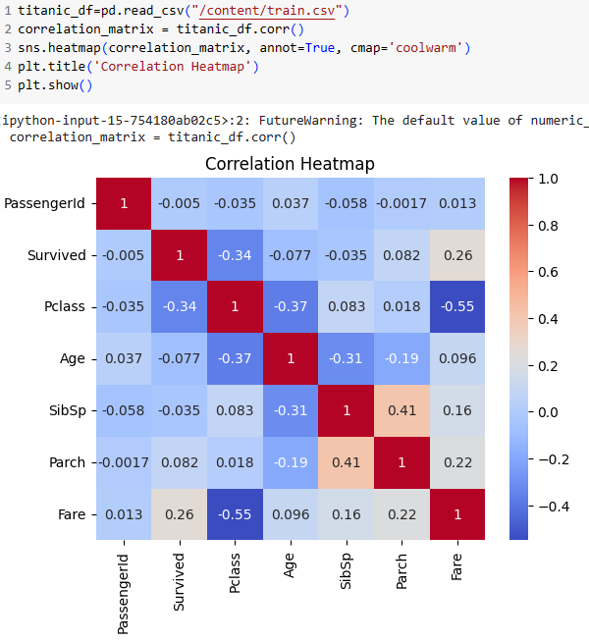

The conclusion is that :

* There is a negative correlation between class and fare, indicating that higher-class tickets were associated with higher fares.
* Age and class are negatively correlated, suggesting that younger passengers were more likely to be in higher classes.
* There is a weak positive correlation between fare and survival, indicating that passengers who paid higher fares had a slightly better chance of survival.